Alexander Baldree
08/27/26
Module 4.2 Assignment
CSD460

GitHub Link:
https://github.com/Panda-Alex21687/CSD440

XAMMP Files: AlexPalindrome.php in htdoc folder;
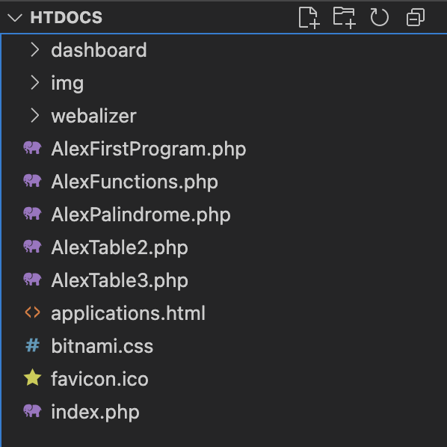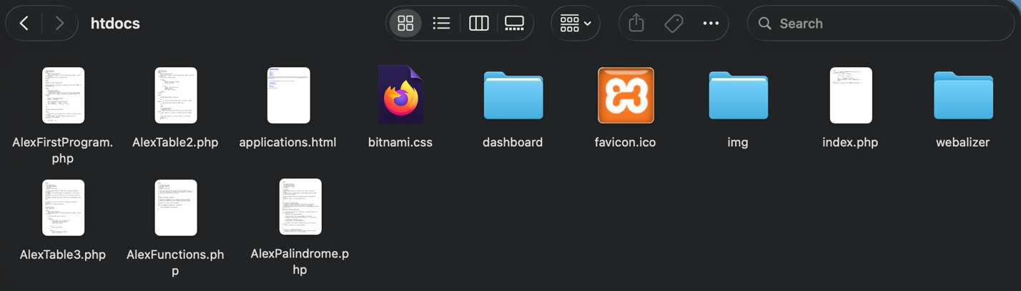

XAMMP running:
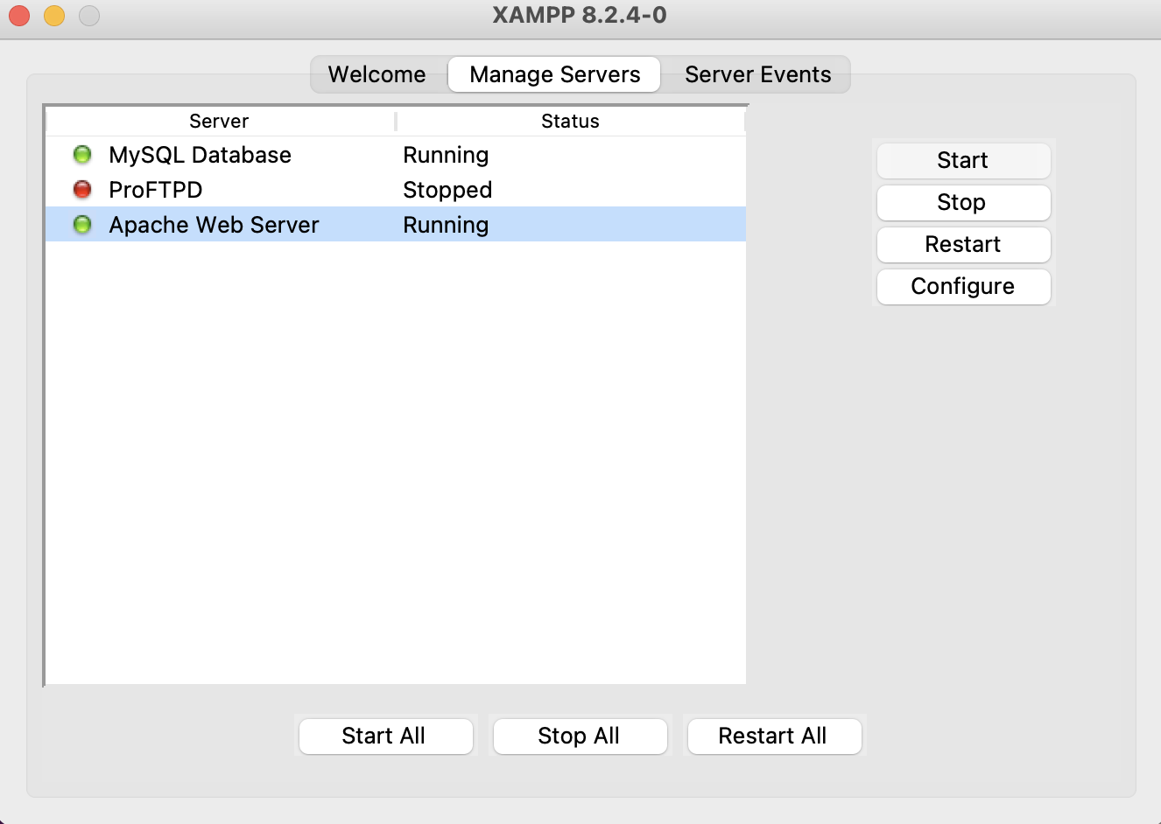

Output:
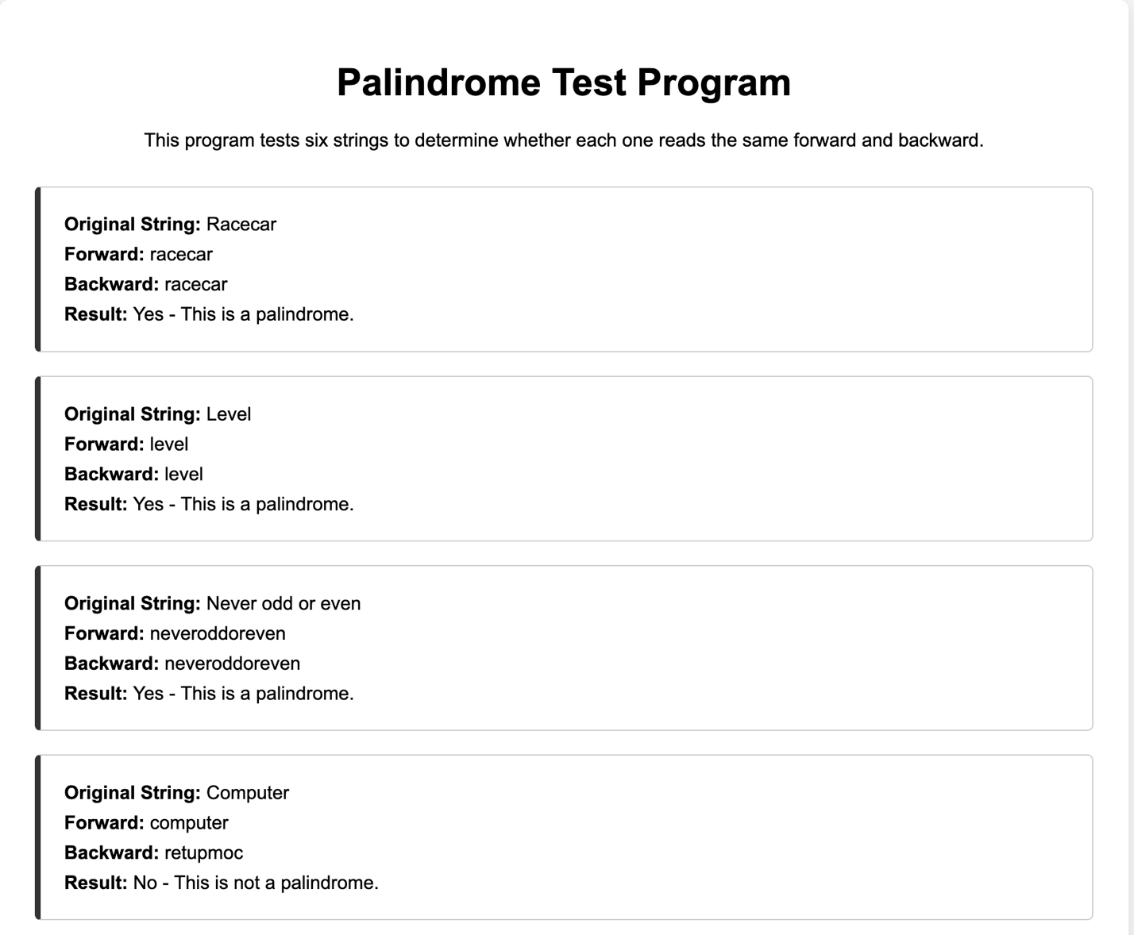
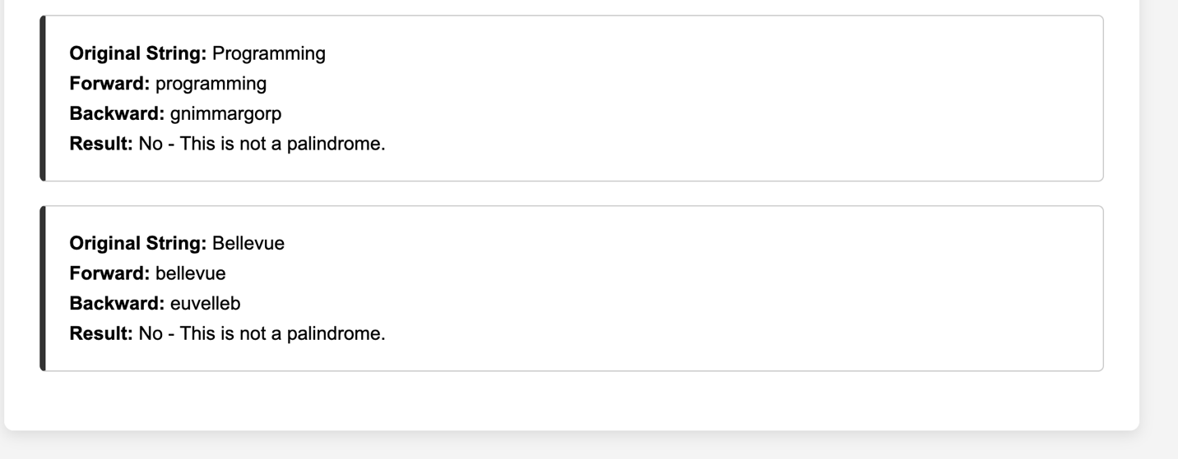

Localhost/AlexPalindrome.php:
